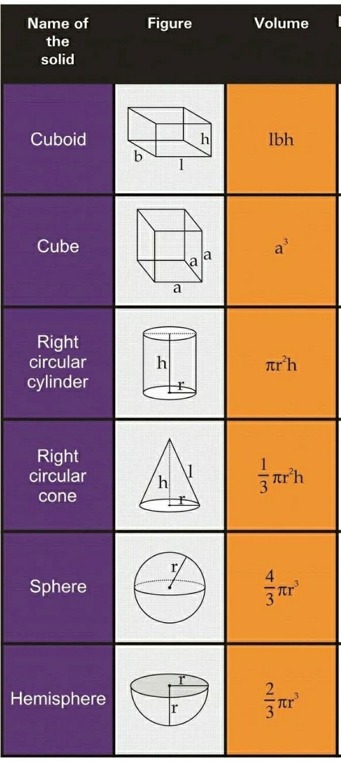

**Atomic Energy Education Society**

**Class:-IX Sub:- Mathematics**

**Chapter 13- Surface Areas and Volumes**

**Module 3**

.